Classful Addressing (Part 2)

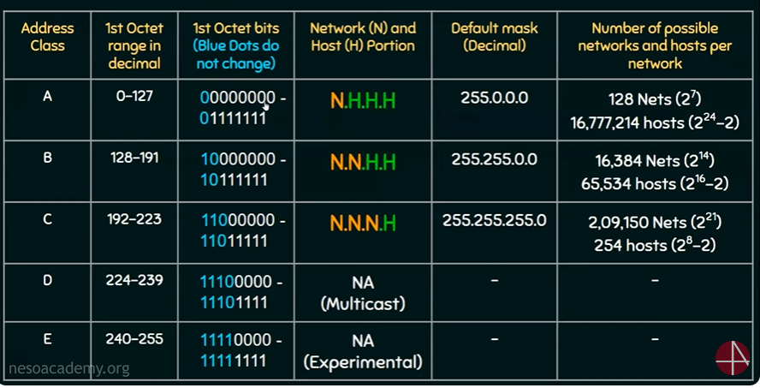

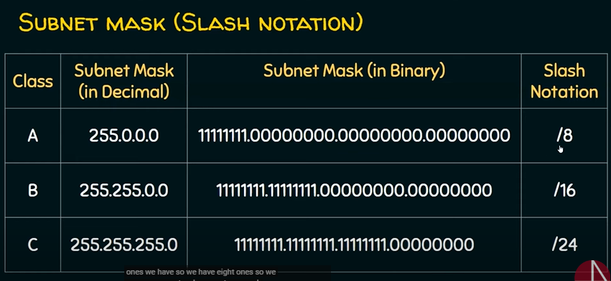

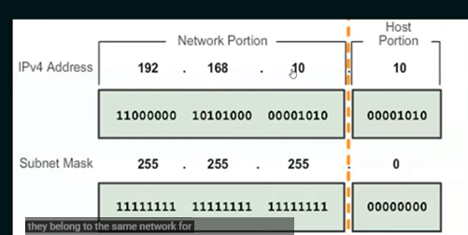

1. To define the network and host portions of an address, devices use a separate 32-bit pattern called a subnet mask.
2. The subnet mask does not actually contain the network or host portion of an IPv4 address, it just says where to look for these portions in a given IPv4 address.